Meteorite Landings

# Project 3, Group 13

### Website: <https://kelseymersinas.pythonanywhere.com/>

## Group Members:

### Zachary Dallas

### Kelsey Mersinas

### Kade Rivers

### Marty Thompson

**Project Details and Purpose**

The intent of this project was for each group to find and prepare a dataset to build a full-stack application with a FLASK backend that queries against an SQLite database. An HTML/JS front-end with some CSS stylings is also utilized along with a Bootswatch theme for Bootstrap, Leaflet for geographical maps using latitude and longitude, and Python Anywhere for website deployment. Group 13 landed on a Kaggle Dataset titled “Meteorite Landings” with data from The Meteoritical Society that needed minimal cleaning in order to focus on the database and website creation. Tasks were discussed and divided amongst team members to complete the project.

The purpose of this project for group 13 was to provide insightful analysis to the meteorite landings and their distributions. NASA estimates that several meteorites can be seen falling through our atmosphere every hour, and that while most burn up, several thousand will still land on our planet each year. Group 13 was able to create interactive maps to visualize the meteorite landings with the intent to highlight the impact of meteorites on our plant and show the distributions.

**Data Cleaning and Database Creation**

The data was fairly clean with some rows with null values that would impact the creation of the database that were removed. Jupyter Notebooks were initially used to visualize beginning sorts and trends within the data for the group to determine the direction for the website graphs and maps, and an SQLite database was created per the project requirements that group members were able to access via DB Browser for SQLite.

Queries were created based on data with locations based around the world for hundreds of years and included points of reference to visualize such as latitude and longitude to create maps, mass of the meteorites, and classifications. The name of the meteorite is often listed as a distinct name or the location in which it was found, and this information is able to tell users more than a simple ID number or a pinpoint on a map.

**Color design considerations**

Due to the nature of the project being meteorite landings, color design considerations were taken from colors of the galaxy and NASA. The Bootswatch theme was chosen by the group to be bright and visible to allow the materials and theme to stand out and show creativity like the Aurora’s. The Google Slides template was selected from Slides.go for the galaxy backgrounds.

**Website architecture**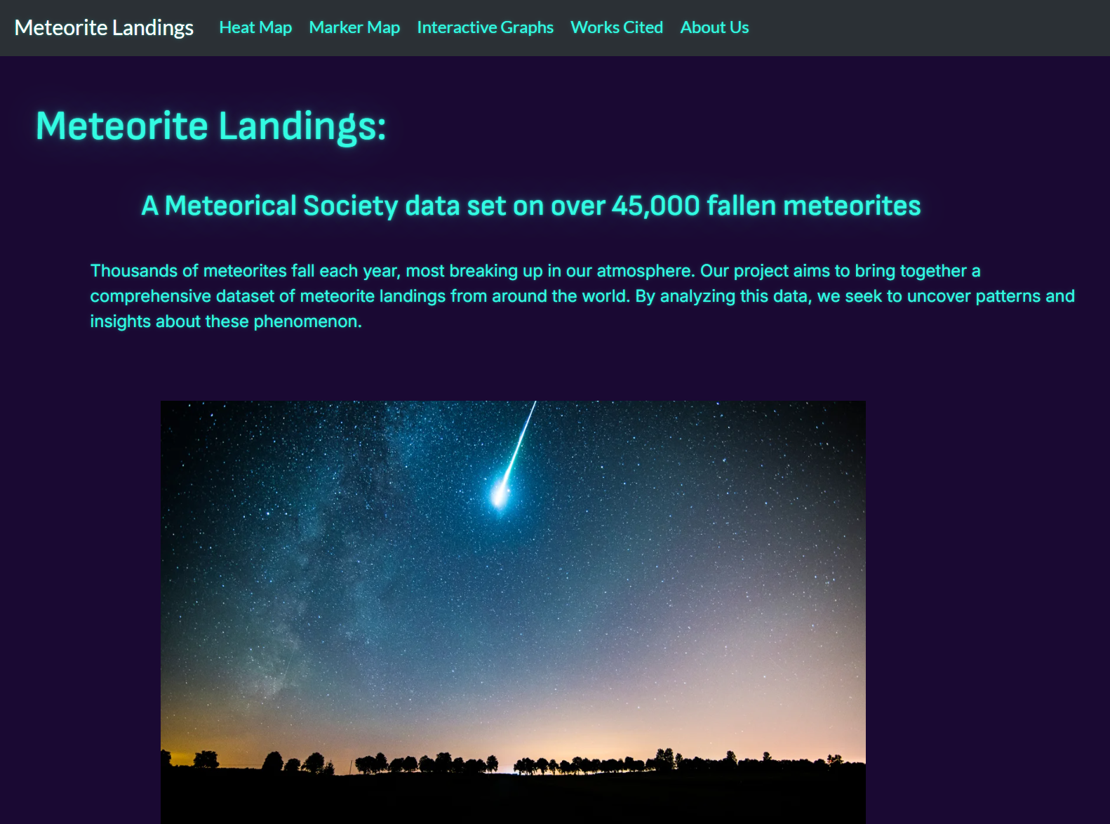

The website is deployed using Python Anywhere. An HTML template was created and used for each page within the website, and seven different javascript files were created for the various pages, maps, graphs, sources, and the usage of leaflet-heat for the heatmap to ensure accuracy and a smooth deployment. Users are able to click the tabs to view and interact with both the website and the visualizations.

**Dashboard design concepts**

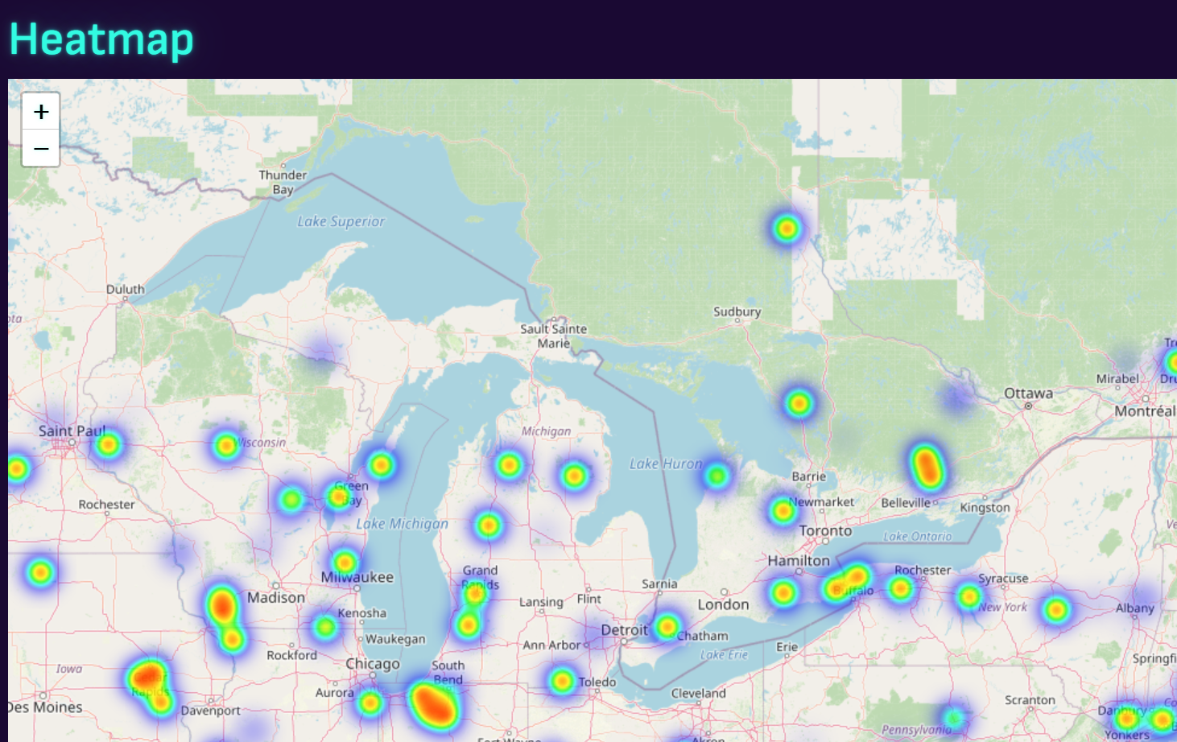

The dashboard was designed to easily access the pages of the website using tabs and titles of the pages or images being viewed. The separation of each visualization on different pages and tabs allowed group members to work both individually on visualizations and be able to easily work in the same repository without merge conflicts. The dashboard is clear and concise for usability, and the color theme is vibrant and exciting for users to enjoy going over data about meteorite landings.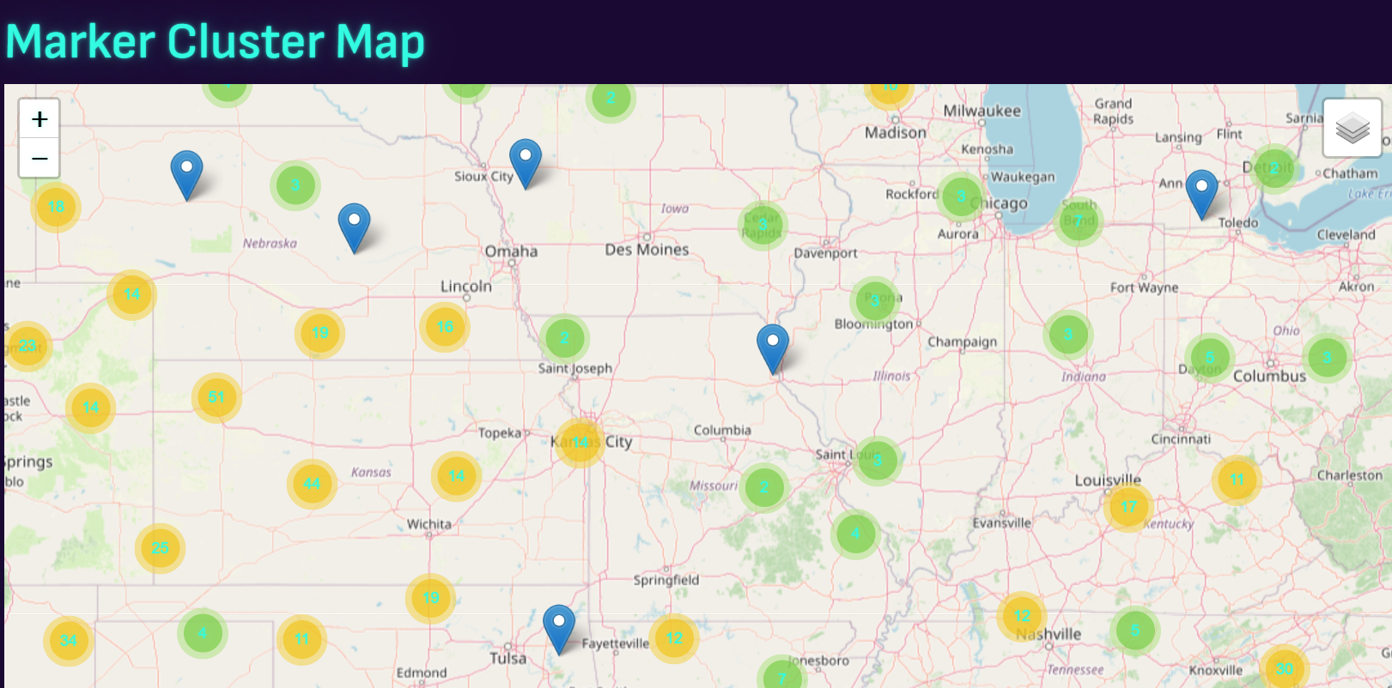

The use of maps in this project was vital to be able to see the landings of meteorites over a span of time across the earth. The maps help to visualize patterns of where meteorites are most commonly found or have landed and where terrain or communication issues may have arisen in collecting complete data on the landings. A heat map was created to show the mass of the landings with darker colors based on higher mass of landings. Zooming out will show higher concentrations of landings while zooming into each meteorite individually allows an “on click” popup to display the name, year, classification, and mass for further information about individual landings. The marker map is used to pinpoint more subtle trends and can show more details about meteor showers and their locations. A line graph displaying the size and frequency allows users to look for rates of increase or decrease in meteorite landings. The graphs also allows users to break down the data into digestible chunks for deeper exploration.

**How does your dashboard answer your research questions?**

Our research questions were the following:

1. Are there any common locations where meteorites are touching down?
2. What are the sizes of these meteorites when they get to earth and are the sizes affecting their landing?
3. Has the frequency of these landings changed over time.

Our dashboard helps to answer our first question by having both a heat map with the mass and the marker map with the number of markers to visualize overall mass of the landings based on location as well as individual markers that cluster together to show just how many landings are in each area that have been documented within this data set. Seeing the regions of the landings also indicates that more traveled and easier terrain makes it easier to find and document the landings versus more difficult terrain or areas less civilized.

Question two is answered with the maps as well and shows us that while the size may not affect the landing spot, however, it does appear that when a larger meteorite lands, smaller meteorites seem to accompany the larger landing.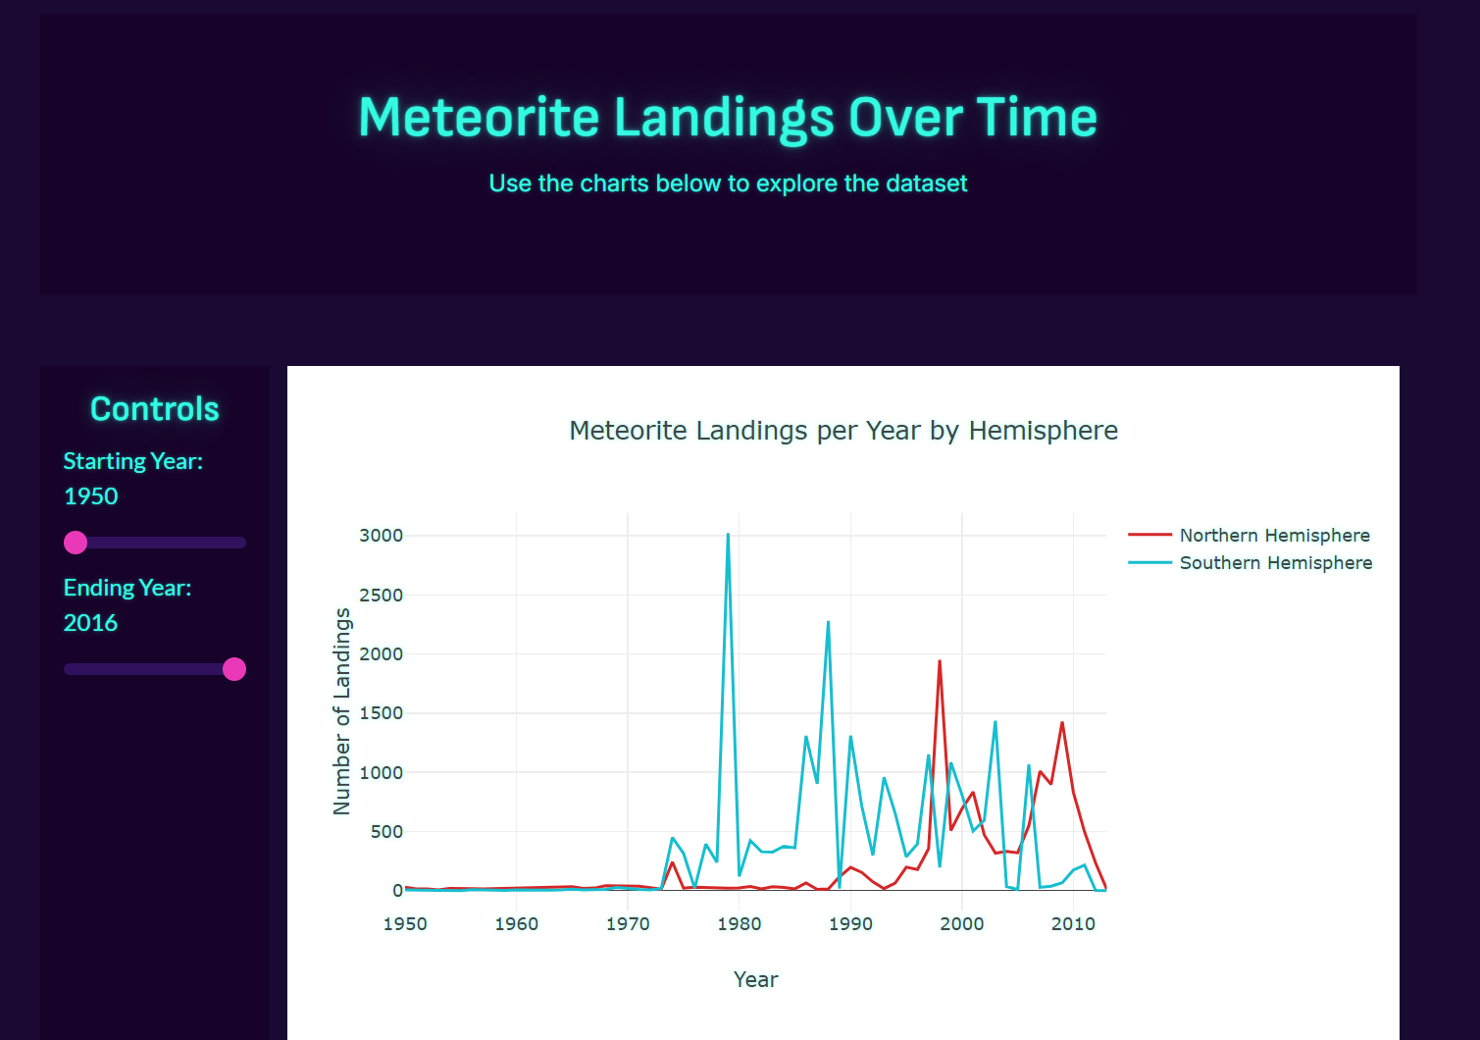

Question three uses the time visualizations and does indicate that meteorite landings seem to have increased over time, however, this is not necessarily a useful correlation because of the advances of science, technology, and reporting of landings.

**Bias/Limitations**

As with any research project and presentation, the more you explore and visualize the data, the more questions you are able to ask. The limitation of time and the current dataset prevented the group from diving into meteorite classifications and the data surrounding those classifications. It also increased questions about the variance of meteorite landings and discoveries based on location, terrain, and NASA. The dataset may have had previous landings, but was fairly sparse until approximately 1970.

**Future Research and Reflection**

Discussions on future research and visualizations included doing more research on the classification-types as well as organizing by classification to determine if similarly classed meteorites land in similar places or if the classification of the meteorites seems random across the earth. Additional research could be dedicated toward the outlier years to determine why the number of landings may have been impacted. Overall the group worked well as a team to collaborate on the project and answer the research questions while accomplishing the assigned project materials.

**Works Cited**

Data Set:

Kaggle.com https://www.kaggle.com/datasets/nasa/meteorite-landings?resource=download

Slides Color Pallette:

slidesGo https://slidesgo.com/

Site Color Theme:

bootswatch.com https://bootswatch.com/vapor/

Title Image:

scientificamerican.com https://static.scientificamerican.com/sciam/cache/file/2ECDAE9E-36E8-49A1-96AEA9BD5CFF4908_source.jpg?w=1200